**Exercise 4: Creating and Configuring a Maven Project**

**Scenario:**

You need to set up a new Maven project for the library management application and add Spring dependencies.

**Steps:**

1. **Create a New Maven Project:**
   * Create a new Maven project named **LibraryManagement**.

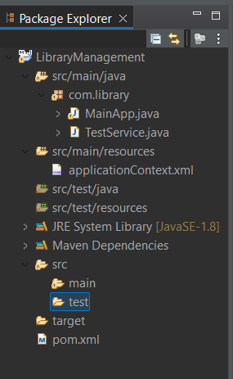

1. **Add Spring Dependencies in pom.xml:**
   * Include dependencies for Spring Context, Spring AOP, and Spring WebMVC.
2. <project xmlns="http://maven.apache.org/POM/4.0.0"
3. xmlns:xsi="http://www.w3.org/2001/XMLSchema-instance"
4. xsi:schemaLocation="http://maven.apache.org/POM/4.0.0
5. http://maven.apache.org/xsd/maven-4.0.0.xsd">
6. <modelVersion>4.0.0</modelVersion>
7. <groupId>com.library</groupId>
8. <artifactId>LibraryManagement</artifactId>
9. <version>1.0-SNAPSHOT</version>
10. <dependencies>
11. <!-- Spring Core Context -->
12. <dependency>
13. <groupId>org.springframework</groupId>
14. <artifactId>spring-context</artifactId>
15. <version>5.3.32</version>
16. </dependency>
17. <!-- Spring AOP -->
18. <dependency>
19. <groupId>org.springframework</groupId>
20. <artifactId>spring-aop</artifactId>
21. <version>5.3.32</version>
22. </dependency>
23. <!-- Spring MVC -->
24. <dependency>
25. <groupId>org.springframework</groupId>
26. <artifactId>spring-webmvc</artifactId>
27. <version>5.3.32</version>
28. </dependency>
29. <!-- SLF4J Logging -->
30. <dependency>
31. <groupId>org.slf4j</groupId>
32. <artifactId>slf4j-api</artifactId>
33. <version>1.7.36</version>
34. </dependency>
35. <dependency>
36. <groupId>org.slf4j</groupId>
37. <artifactId>slf4j-simple</artifactId>
38. <version>1.7.36</version>
39. </dependency>
40. </dependencies>
41. <build>
42. <plugins>
43. <!-- Compiler Plugin -->
44. <plugin>
45. <groupId>org.apache.maven.plugins</groupId>
46. <artifactId>maven-compiler-plugin</artifactId>
47. <version>3.8.1</version>
48. <configuration>
49. <source>1.8</source>
50. <target>1.8</target>
51. </configuration>
52. </plugin>
53. </plugins>
54. </build>
55. </project>
56. </project>

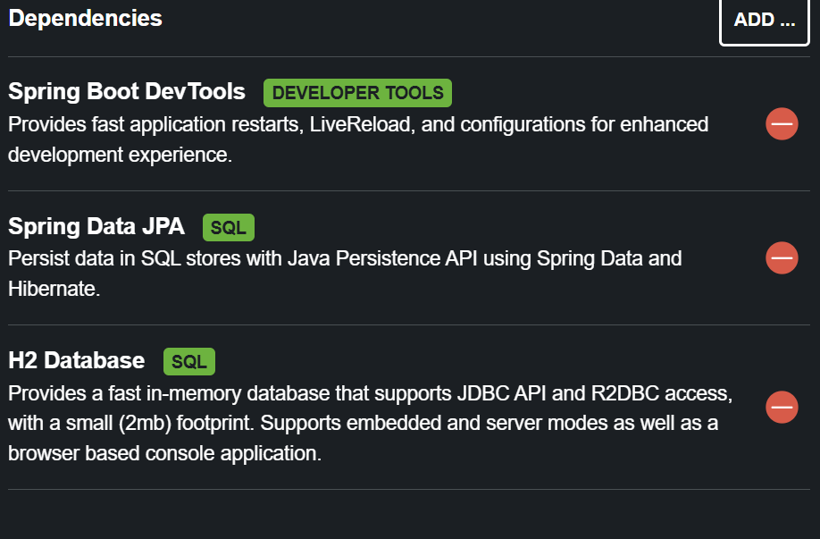

1. **Configure Maven Plugins:**
   * Configure the Maven Compiler Plugin for Java version 1.8 in the pom.xml file.

**localhost:8080**